**Difference between Window and Document Object**

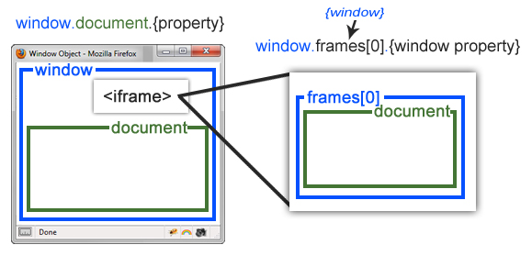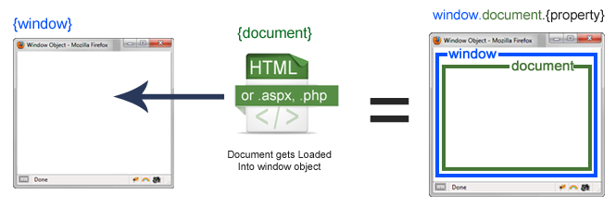Window object and Document object are not the same.

**Window Object:**

* The window is the first thing that gets loaded into the browser.
* This window object has the majority of the properties like length, innerWidth, innerHeight, name, if it has been closed, its parents, and more.
* If we want to access a property for the window it is window.property.
* The iframe is also a window object. An iframe actually is considered as a new window with its own document loaded into it. The original, parent window, is responsible for other windows to be loaded, not the document.
* The property to access a frame is window.frames[], which is an array of all the frames. If you only have one iframe you access it by using window.frames[0]. Since the iframe is also a window object, accessing window properties of that frame is done by using window.frames[0].mywindowproperty.

**Document Object:**

* The document object is loaded other documents such as html, aspx, php, or other document that will be loaded into the browser.
* The document actually gets loaded inside the window object and has properties available to it like title, URL, cookie, etc.
* If it is document it is window.document.property which is also available in short as document.property.

| **document** | **window** |
| --- | --- |
| It represents any HTML document or web page that is loaded in the browser. | It represents a browser window or frame that displays the contents of the webpage. |
| It is loaded inside the window. | It is the very first object that is loaded in the browser. |
| It is the object of window property. | It is the object of the browser. |
| All the tags, elements with attributes in HTML are part of the document. | Global objects, functions, and variables of JavaScript are members of the window object. |
| We can access the document from a window using the window. document | We can access the window from the window only. i.e. window.window |
| The document is part of BOM (browser object model) and dom (Document object model) | The window is part of BOM, not DOM. |
| Properties of document objects such as title, body, cookies, etc can also be accessed by a window like this window. document.title | Properties of the window object cannot be accessed by the document object. |
| syntax:        document.propertyname; | syntax:  window.propertyname; |
| example:       document.title :  will return the title of the document | example:  window.innerHeight : will return the height of the content area of the browser |